1. Frontend vs. Backend vs. Full-Stack Development
Think of a website as a restaurant. 🍽️
- Frontend (Client-Side): This is the part of the restaurant you interact with—the dining area. It includes the tables, menus, decor, and the waiter who takes your order. In web development, the frontend is everything the user sees and interacts with in their browser. It's built using technologies like HTML (for structure), CSS (for styling), and JavaScript (for interactivity).
  - Example: On Amazon's product page, the frontend is the layout of the images, the product description text, the color of the "Add to Cart" button, and what happens when you click it.
- Backend (Server-Side): This is the kitchen of the restaurant. You don't see it, but it's where your order is received, the food is cooked, and all the magic happens. The backend is the "behind-the-scenes" machinery of a website. It includes the server, the application logic, and the database. It manages user accounts, processes payments, and fetches data. It's built using languages like Python, Java, Node.js, or PHP.
  - Example: When you click "Add to Cart" on Amazon, the backend code running on Amazon's server updates your shopping cart, checks if the item is in stock, and processes your payment information securely.
- Full-Stack: A full-stack developer is like a restaurant owner who can work as the host, the waiter, and the head chef. They are comfortable working on both the frontend and the backend, understanding how the client and server sides communicate and operate together.

2. The Client-Server Model
The client-server model is the fundamental structure of the web. The client (your web browser) requests information, and the server (a powerful computer storing the website) responds with that information.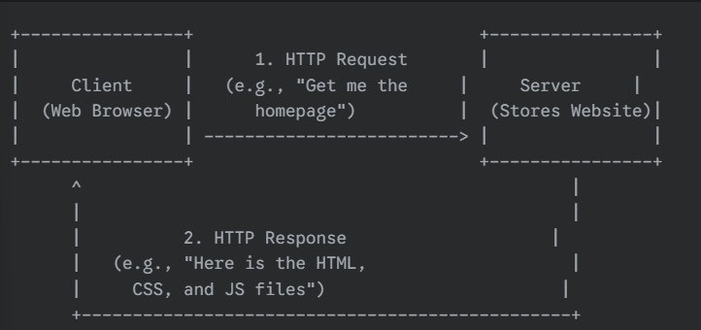

3. How a Browser Displays a Web Page
When you type a URL into your browser and hit Enter, a multi-step process begins to fetch and display the page:
- URL to IP Address: You type a domain name (e.g., www.google.com). The browser uses the DNS (Domain Name System), which acts like the internet's phonebook, to find the unique IP address (e.g., 142.250.195.100) of the server where the website is stored.
- HTTP Request: The browser sends an HTTP (Hypertext Transfer Protocol) Request message to the server at that IP address, asking for the web page.
- Server Response: The server receives the request, finds the necessary files (HTML, CSS, JavaScript, images), and sends them back to the browser in an HTTP Response. This response includes a status code (e.g., 200 OK means everything is fine).
- Rendering: The browser starts receiving the files.
  - It first parses the HTML to build the structure of the page, called the DOM (Document Object Model).
  - It then parses the CSS to figure out the styling (colors, fonts, layout).
  - Finally, it executes the JavaScript to add interactivity, like animations or form validations.
- Display: The browser combines the structure (HTML) and styling (CSS) to "paint" the final, visible web page onto your screen.
—----------------------------------------------------------------------------------------------------------------------------

4. Web Development Environment Tools
To start building websites, you need a few essential tools on your computer.
- Code Editor: This is a text editor designed for writing code. It provides features like syntax highlighting (coloring your code to make it readable) and autocompletion.
  - Purpose: To write and edit HTML, CSS, and JavaScript files.
  - Examples: Visual Studio Code (VS Code), Sublime Text, Atom.
- Web Browser: This is the application you use to view websites. For development, its built-in developer tools are crucial for debugging and testing.
  - Purpose: To render your code and test how your website looks and functions.
  - Examples: Google Chrome, Mozilla Firefox, Microsoft Edge.
- Version Control System (VCS): This tool tracks changes to your code over time. It's like having a "save" button for every stage of your project, allowing you to undo mistakes and collaborate with others.
  - Purpose: To manage your project's history and work with a team.
  - Example: Git is the industry standard.
- Command Line Interface (CLI): A text-based interface for interacting with your computer. It's used for running commands for Git, build tools, and managing local servers.
  - Purpose: To execute commands and manage development tasks efficiently.
  - Examples: Terminal (macOS/Linux), PowerShell (Windows).

5. Web Servers
A web server is software and hardware that stores website files and delivers them to a user's web browser upon request. Its primary job is to "serve" web pages. When you visit a website, your browser is sending a request to that site's web server.
- Hardware: A physical computer that is always connected to the internet and contains the website's files.
- Software: An application (like Apache or Nginx) that runs on the hardware, understands URLs, and handles HTTP requests from browsers.
Commonly used web servers include:
- Apache HTTP Server: One of the oldest and most widely used open-source web servers.
- Nginx: A high-performance web server known for its speed and efficiency. It's also often used as a reverse proxy and load balancer.
- Microsoft IIS (Internet Information Services): A web server developed by Microsoft for Windows operating systems.

6. Project Roles
In a typical web development project, responsibilities are divided among specialized roles.
- Frontend Developer: This person is responsible for the user interface (UI) and user experience (UX). They take the visual design and bring it to life with code, ensuring the website is responsive, accessible, and interactive. They are masters of HTML, CSS, and JavaScript.
- Backend Developer: This person builds and maintains the server-side of the application. They work with databases, write application logic, create APIs, and handle security and performance. They use languages like Python, Node.js, Java, or PHP.
- Database Administrator (DBA): This is a specialist who manages the database. They are responsible for designing the database structure, ensuring data integrity, security, backups, and optimizing queries to make sure the application can retrieve data quickly and reliably.

7. Installing and Configuring VS Code
I can't install software on your machine, but I can guide you through the process.
- Download and Install:
  - Go to the official Visual Studio Code website: https://code.visualstudio.com/
  - Download the installer for your operating system (Windows, Mac, or Linux).
  - Run the installer and follow the on-screen instructions.
- Configure for Web Development (Install Extensions): Extensions add powerful features to VS Code.
  - Open VS Code.
  - Click the Extensions icon in the Activity Bar on the left side of the screen (it looks like four squares).
  - Search for and install the following essential extensions by clicking the "Install" button:
    - Live Server: Launches a local development server with a live reload feature. When you save your code, the browser automatically refreshes.
    - Prettier - Code formatter: Automatically formats your code to be clean and consistent every time you save.
    - ESLint: Helps you find and fix errors in your JavaScript code.
    - IntelliSense for CSS class names in HTML: Autocompletes CSS class names in your HTML files.
- Screenshot:
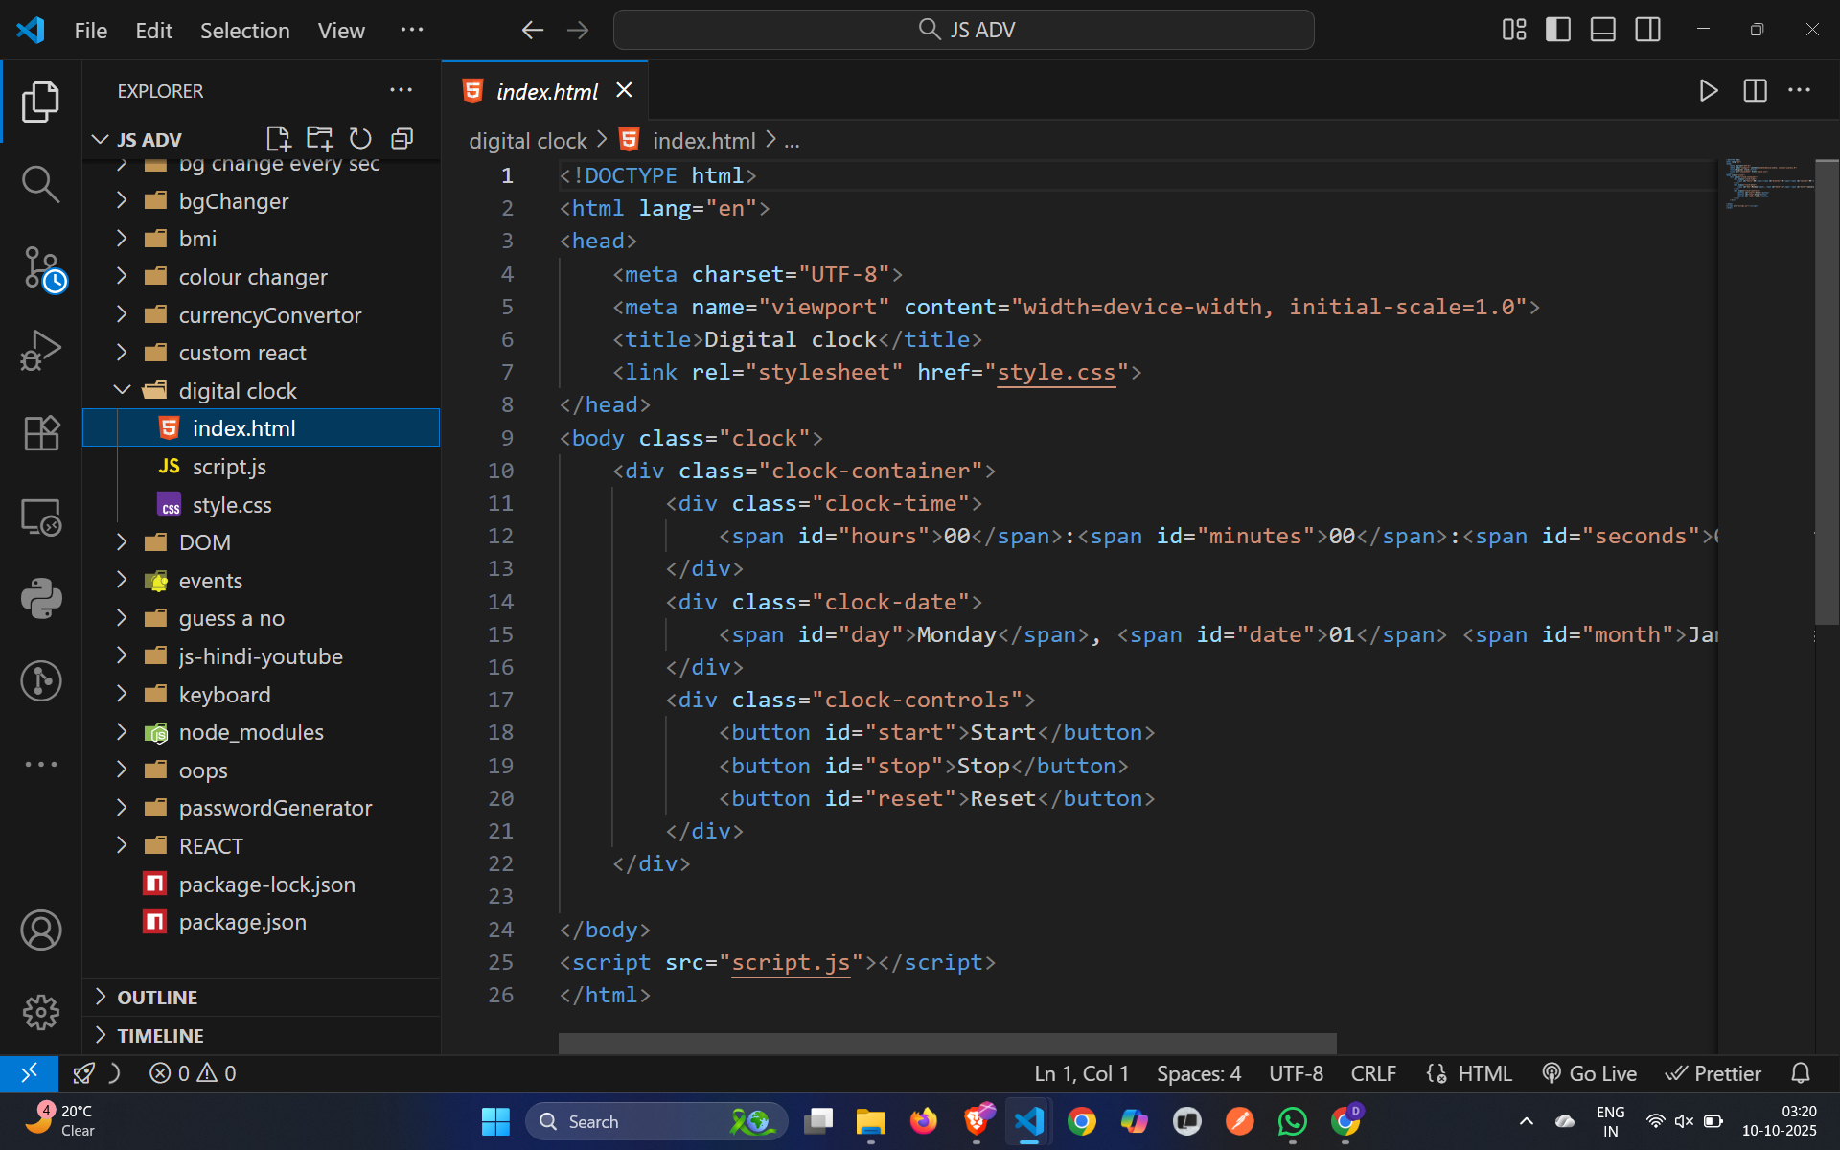

8. Static vs. Dynamic Websites
The key difference is how the content is generated and delivered.
- Static Websites:
  - The content is fixed. The web server sends the exact same HTML, CSS, and JavaScript files to every user. The content only changes when a developer manually updates the files on the server.
  - Analogy: A printed brochure. The information is the same for everyone who reads it.
  - Example: A simple personal portfolio, a landing page for a product, or a restaurant's menu page.
- Dynamic Websites:
  - The content is generated on-the-fly by the server before being sent to the browser. It can be personalized based on the user, time of day, location, or other data stored in a database.
  - Analogy: A social media feed. Your feed is unique to you and constantly updated with new posts.
  - Example: Facebook (shows your personal news feed), Amazon (shows personalized product recommendations), and news websites (show the latest articles).

9. Web Browsers and Rendering Engines
Here are five popular web browsers and the rendering engines that power them. A rendering engine is the core component that takes HTML and CSS and turns it into the visual page you see.
- Google Chrome: Uses the Blink rendering engine.
- Mozilla Firefox: Uses the Gecko rendering engine.
- Apple Safari: Uses the WebKit rendering engine.
- Microsoft Edge: Uses the Blink rendering engine (it switched from its own engine, EdgeHTML, in 2019).
- Brave: Also uses the Blink rendering engine.
How They Differ: Blink, Gecko, and WebKit are all separate codebases developed by different organizations (Google, Mozilla, and Apple, respectively). While they all aim to follow web standards set by the W3C, they can have minor differences in:
- Feature Support: A new CSS or JavaScript feature might be implemented in one engine before the others.
- Performance: They may render certain elements or execute JavaScript at different speeds.
- Bug Implementation: Sometimes, an engine might have a bug that causes a website to look slightly different than in other browsers.
This is why web developers must test their sites across multiple browsers—to ensure a consistent and functional experience for all users, regardless of which browser they use.

10. Basic Web Architecture Flow
This diagram shows the complete flow from the user's device to the database and back.
Here is the flow explained:
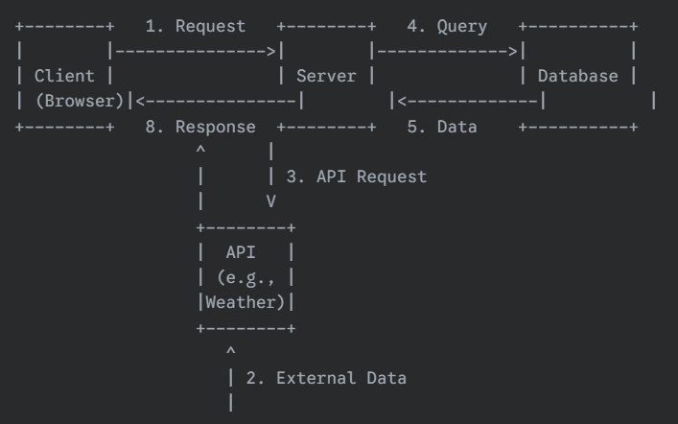
- Client Request: The user interacts with the website in their browser, triggering an HTTP request to the server.
- External API Call (Optional): The server may need data from an external service (like a weather service or payment gateway). It sends a request to that service's API (Application Programming Interface).
- API Response: The external API sends the requested data back to the server.
- Database Query: The server's application logic queries its own database to retrieve or save user-specific data (e.g., get a user's profile).
- Database Response: The database returns the requested data to the server.
- (Processing): The server processes all the information from the database and any APIs.
- Server Response: The server bundles everything into an HTML page (or data format like JSON) and sends it back to the client as an HTTP response.
- Render: The client's browser receives the response and renders the final page for the user to see.

